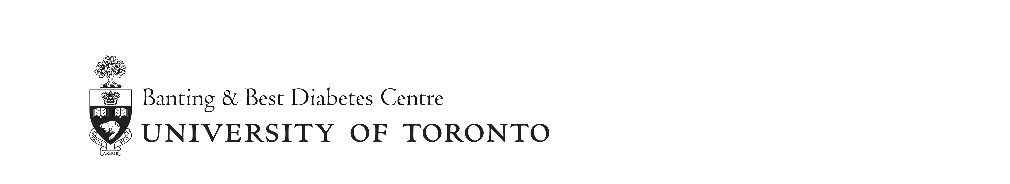

Banting & Best Diabetes Centre
Charles Hollenberg Summer Studentship Program 2018
Potential Supervisor List

Last Updated: November 7, 2017

Below is a list of supervisors who potentially have one or more positions available for a summer student. All are U of T faculty involved in diabetes-related research and are members of the Banting & Best Diabetes Centre.

Dr. Patricia Brubaker p.brubaker@utoronto.ca
Dr. Satya Dash satya.dash@uhn.ca
Dr. Julie Lovshin julie.lovshin@sunnybrook.ca
Dr. Farid Mahmud farid.mahmud@sickkids.ca
Dr. Maria Rozakis Maria.Rozakis@utoronto.ca
Dr. Walter Swardfager w.swardfager@utoronto.ca
Dr. Michael Wheeler michael.wheeler@utoronto.ca
Dr. Sara Vasconcelos sara.vasconcelos@utoronto.ca
Dr. Xiao-Yan Wen x.wen@utoronto.ca
Dr. Catherine Yu YuCa@smh.ca

